**202280-Fall 2022-ITIS-6120-081-Applied Database**

**Prof. Yaorong Ge, PhD**

1. List the entity tables and association tables in this database. Provide a brief explanation of your decision.  
     
   Entity Tables: Country  
    Country can be considered as Entity as it’s the primary point of data capture. It is not dependent on properties or fields from other tables  
     
   Associate Tables: City, CountryLanguage  
    City and CountryLanguage are associate tables as they are dependent of the properties of Country table attributes.
2. Use the Reverse Engineering feature of the MySQL Workbench to draw an ER diagram of this database. Make some adjustments to the diagram and submit a screenshot that is different from the original diagram.  
     
   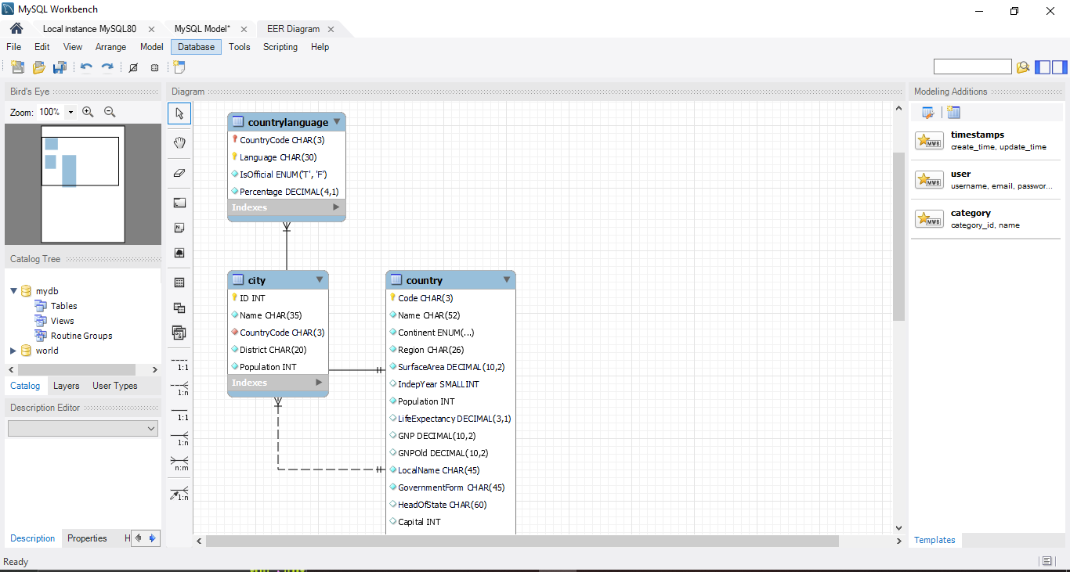  
     
   Edited:   
     
   